**ENGR 122 Homework 5**

**NOTE:** Use engineering format for problems 1-4. Use non-engineering format for problems 5-9. This is an individual assignment.

1. For the beam below, find the reaction forces at pinned joint A and roller joint D. Ay = 1221.54lb, Ax = 168.71lb, and D = 1009.24lb

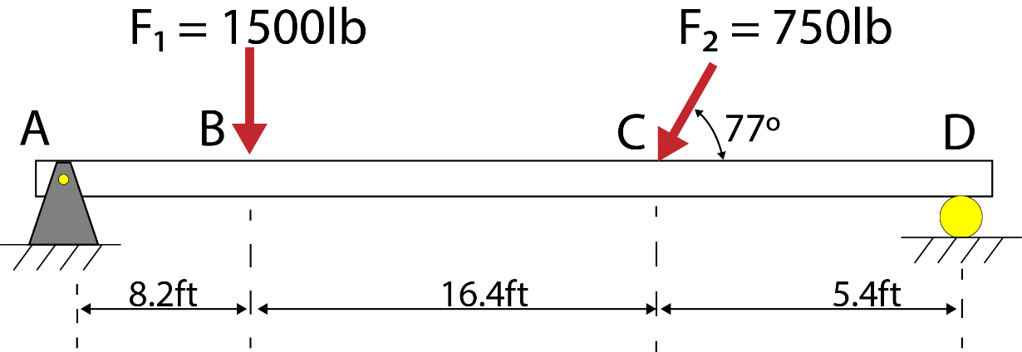

**Given: F1=1500lb, F2=750lb, d=8.2,16.4, 5.4ft**

**Request: Ay, Ax, D**

**Solution:**

**Ax=F2cos77=75cos77**

**Ax=168.71 lb**

**Ax+D=F1+F2sin77**

**=1500+(750*sin77)**

**=2230.78 lb**

**∑MA=0 =(1500*8.2)+(750*sin77*24.6)-(Dy*30)=0**

**=12300+17977.13=30Dy**

**D=1009.24lb**

**Ay=2230.78-1009.24**

**Ay=1221.54lb**

1. Rework problem 1 to derive equations for the reaction forces Ax, Ay and D as a function of angle θ. Plot these equations using Mathcad on a single graph where θ ranges from 0˚ to 180˚ in increments of 5˚. The single graph should include …
   1. the reaction force Ax in terms of θ;
   2. the reaction force Ay in terms of θ; and
   3. the reaction force D in terms of θ.

1. For the truss below, find the reaction forces at pinned joint A and roller joint D. Although the roller joint is drawn with three rollers, it behaves like the roller at point D in problem 1. When you draw the FBD, you can represent the reaction force at the roller using a horizontal force acting to the left at D. **Note:** The internal forces in the truss members (such as the tension in member AB) does not show up on the FBD; only the external forces and reactions should appear on the FBD (reactions at A and D as well as the external loads at B and C).

D = 9.87kN, Ax = 9.87kN, and Ay = 14.6kN

*A* ***truss*** *is a framework used as a support structure in applications like roofs, bridges, and many other structures.*

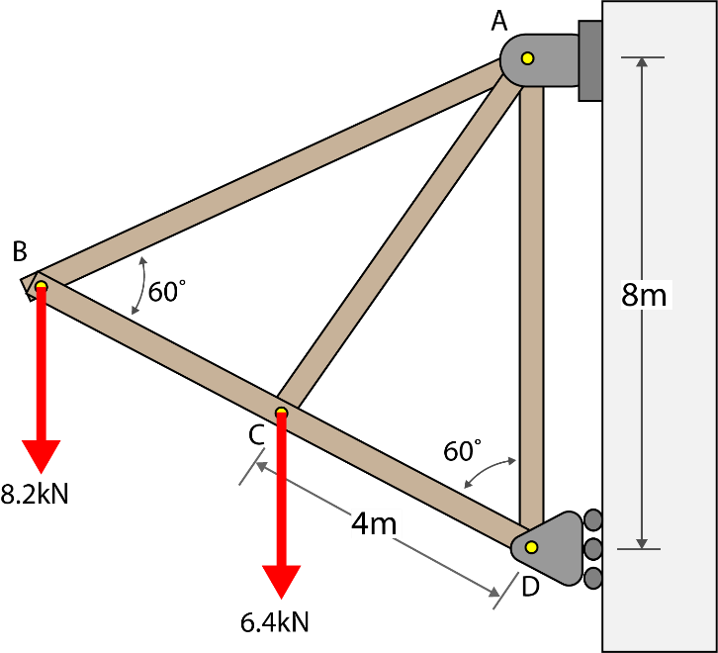

**Given: θ=60, F=6.4,8.2kN, d=8,4m**

**Request: D, Ax, Ay**

**Solution:**

**∑y=0**

**Ay=6.4+8.2=14.6 kN**

**∑MA=0**

**D*8-8.2*3.46*2-6.4*3.46=0**

**D=9.87kN**

**∑x=0**

**Ax+D=0**

**Ax=-D=-9.87 kN**

1. A stunt motorcycle driver rides a wheelie across a 25m long bridge at an angle θ to a horizontal plane. The combined weight of the rider and the motorcycle is 2.45 kN (about 550 lbs). Determine the reactions at A and C for x = 8 m and θ = 22°. Hint: Shifting your coordinate system may make this problem easier to solve. C = 0.73kN, Ax = 0.92kN, and Ay = 1.54kN

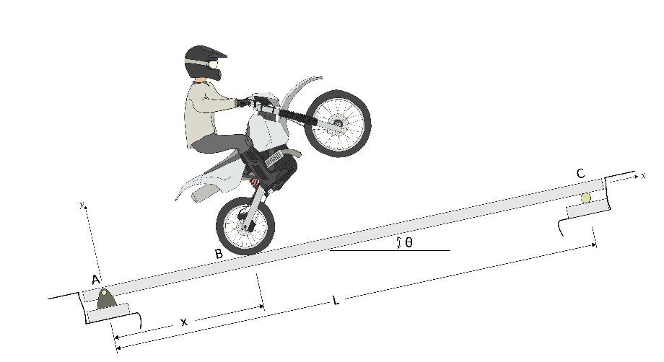

**Given: d=25, θ=22, F= 2.45, x=8**

**Request: C, Ax, Ay**

**Solution: ∑fy=Ay+c=2.45cos22**

**∑fx=Ax+cx=2.45sin22**

**Ax=0.917786=0.92kN**

**∑MA=0**

**8*2.45cos22-c*25=0**

**C=0.78 kN**

**Ay+0.7269=2.45cos22**

**Ay=1.54 kN**

1. Write a program to perform some action of your choosing in the main loop of an Arduino sketch. Implement the interrupt command discussed in class to respond to the input from a switch. When the switch is pressed have the interrupt command tell the Arduino to perform some other action of your choosing independent from the main loop actions.

Examples of actions that you can program: light/blink and LED, read temperature on thermistor, detect objects using IR, spin servos, make a speaker sound, and change color of RGB LED. You are not limited to this list. Your code must be different from the code provided in the presentation.

Note: Have your Arduino/circuit out on your table with the program running so that your instructor or class assistant can quickly check your work. Do not turn your homework in at the front; have it ready so that the instructor/assistant can grade the interrupt activity.

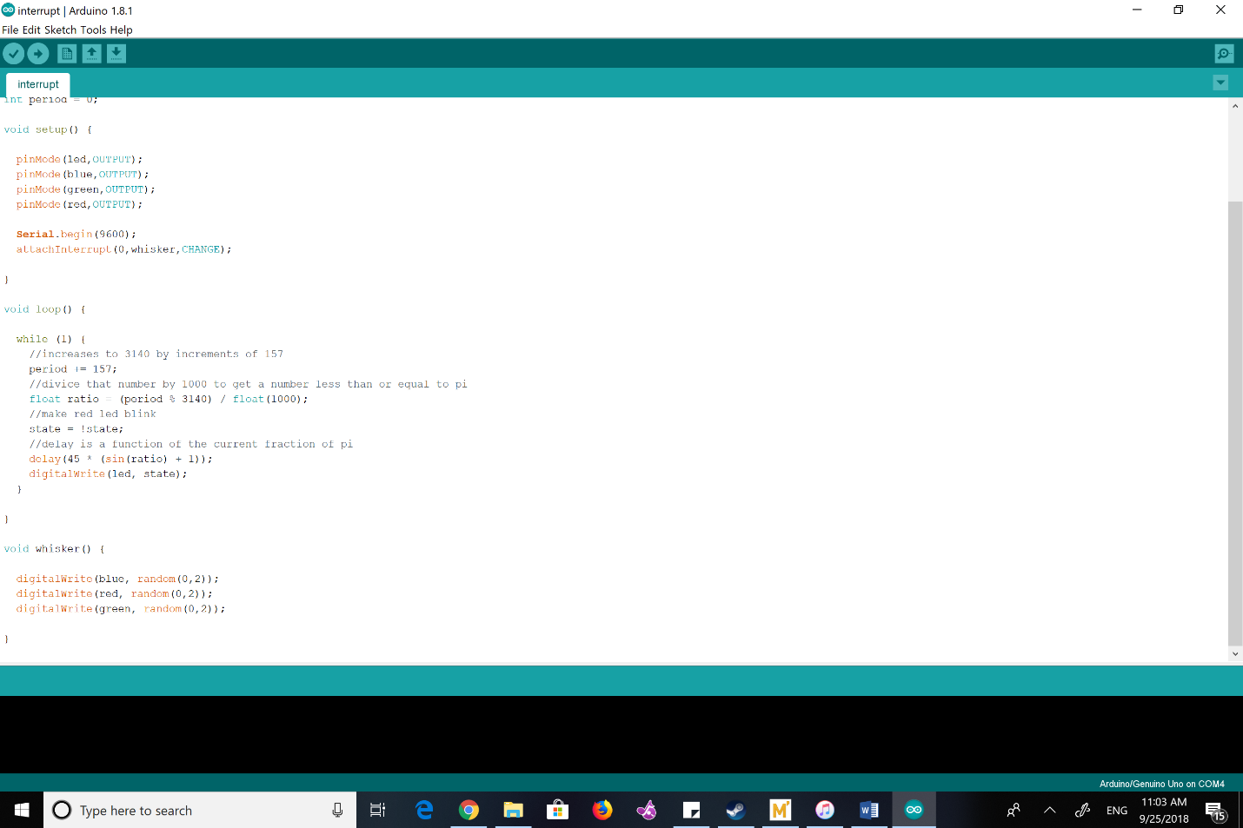

1. Search online for how gears work. Read articles or watch videos about gears. Summarize three different points that you learned about how gears work.

The primary mechanic in gears is that every gear has tooth that interlocks with the set of teeth on another gear. When one of the gears spin, that force is also applied on the other gears in the chain, causing all the gears to spin. The use of this mechanic is usually to covert some other kind of momentum into rotational inertia, or vice-versa. Another thing gears are for is to convert between types of energy. Gear reduction, where a small gear spinning fast turns a large gear at a much lower rate but with a higher torque, and gear multiplication, which is quite the opposite. As a matter of fact, a lot of gearboxes that are produced with the intention of being used as reduction mediums can be easily used as multiplication mediums simply by running them backwards.

1. Review the list of sensors/devices that can be checked out for the ENGR 122 project. Choose one to research in more depth. Write a few sentences about how the sensor/device works. Include some potential applications for the sensor/device.

One of the devices that can be checked out is the discrete semiconductor, also known as a voltage converter. The discrete semiconductor is a type of transistor that only allows a certain amount of voltage to flow across depending on the electric state of the middle terminal. A quick and obvious application that I have in mind is to protect the LED’s we use with our Arduino when we build circuits that run on 5 volts. 5 volts is enough to pop the bulbs, so having one of these semiconductors can allow us to protect them from high voltage without complex resistor additions. Another application that comes to mind, that I’m sure is already in place, is in the interior of vehicles on the battery circuit. Lead batteries in our vehicles produce a much higher voltage than, say, our speakers or cab lights can handle. At some point in that circuit, there is probably one of these converters to protect them from the high voltage of the battery under the hood.

1. Add another idea to your “Idea Wallet” by talking to someone about what bugs them. Their bug can be something that doesn’t work quite right or that could be improved, something that bothers them, or things that they have noticed to cause problems for others. Please name the project idea, state who you talked with, write up at least a two-sentence description of the idea, and provide pictures when it makes sense to do so.

The person that I talked to is a friend of mine named Edward Auttonberry. When I asked him to tell me about something that bothered him or could be improved, he brought up the sound system he has installed in his vehicle. He said that even though the central unit contains a lot of functionality such as hooking straight into IHeartRadio or Pandora, or allowing for USB insertion, he has noticed quite often that there are bugs in the software. He says he would love it if he could reprogram the unit himself through some kind of API so he could fix the things that bother him himself.